0164/103

11th August 2021

-Translation-
Subject: Investment in “Temple I” Gas-fired power plant in USA
To: President of the Stock Exchange of Thailand

Banpu Public Company Limited (“BANPU”) would like to inform the Stock Exchange of Thailand that BKV Corporation (“BKV”) its 96.3% subsidiary and Banpu Power US Corporation (“BPPUS”), 100% subsidiary of Banpu Power Public Company Limited (“BPP”), jointly established BKV-BPP Power LLC (“BKV-BPP) in which BKV and BPPUS equally hold 50% ownership.

On 10th August 2021, BKV-BPP Power LLC has signed a Purchase and Sale Agreement (“PSA”) to purchase 100% interest in Temple Generation Intermediate Holdings II, LLC, the entity that owns Temple 1 power plant located in Texas, USA. The purchase consideration is U$ 430 million or equivalent to THB 14,147 million and is subject to adjustment in accordance with the PSA. This transaction will be funded by our internal cash flow and loan from financial institutions. The transaction is subject to customary terms and conditions and is expected to complete by the 4th quarter of 2021

The Temple I power plant is a Combined Cycle Gas-fired power plant with generating capacity of 768 MW, the plant achieved Commercial Operation Date (COD) since 15th July 2014. It is strategically located in the State of Texas, one of the most concentrated, and rapidly growing, population centers in the US. This power plant is one of the most efficient Combined Cycle Gas Turbines (CCGT) in Electric Reliability Council of Texas (ERCOT) power market, with its high flexibility, efficiency, and equipped with advanced emissions-control technology. This power plant is ideal for the ERCOT market as its competitiveness reflecting in its priority dispatch according to its merit order to serve the dynamic demand pattern in the market. Moreover, as an operating power plant, it can contribute immediate cash flow to BANPU group.

This investment is a significant milestone under our long-term investment strategy and a steppingstone to the power business under wholesale electricity market with advanced trading system and mechanism in the US. It reflects the acceleration of Banpu transformation of its portfolio under Greener & Smarter strategy to embrace future trends and growing towards Smarter Energy for Sustainability.

This investment also reflects the distinctive synergistic value between BKV and BPP as both companies are the main flagships under BANPU group. Through the experience sharing, learning and collaboration from different expertise in each business aim to enhance the highest value creation into the investment. BKV as one of the top 20 natural gas exploration & production company in the US, having experiences and skillful resources-based especially on managing large-scale operations, understand the local rules & regulations, having strong and well-established relationship with all related stakeholders including government agencies and communities within the areas as well as understanding the demand and trading mechanism under ERCOT electricity market. While BPP, an energy generation flagship under BANPU group will contribute its experiences and skill-based resources especially on technical know-how, focusing on increasing efficiency and sustainability in the production process by using High-Efficiency, Low-Emissions (HELE) technologies and committed to continue achieving its growth target. This investment structure has thoroughly been considered in all aspects aim at the highest ability to increase value to the investment and maximize the return to the shareholders.

BANPU certifies that this investment is not a connected transaction and does not trigger the reporting requirement for the acquisition of assets of listed companies under the Notification of Capital Market Supervisory Board.

Please be informed accordingly and kindly disseminate the information herein to investors.

Sincerely yours,
- signature -
(Ms. Somruedee Chaimongkol)
Chief Executive Officer

Investment structure
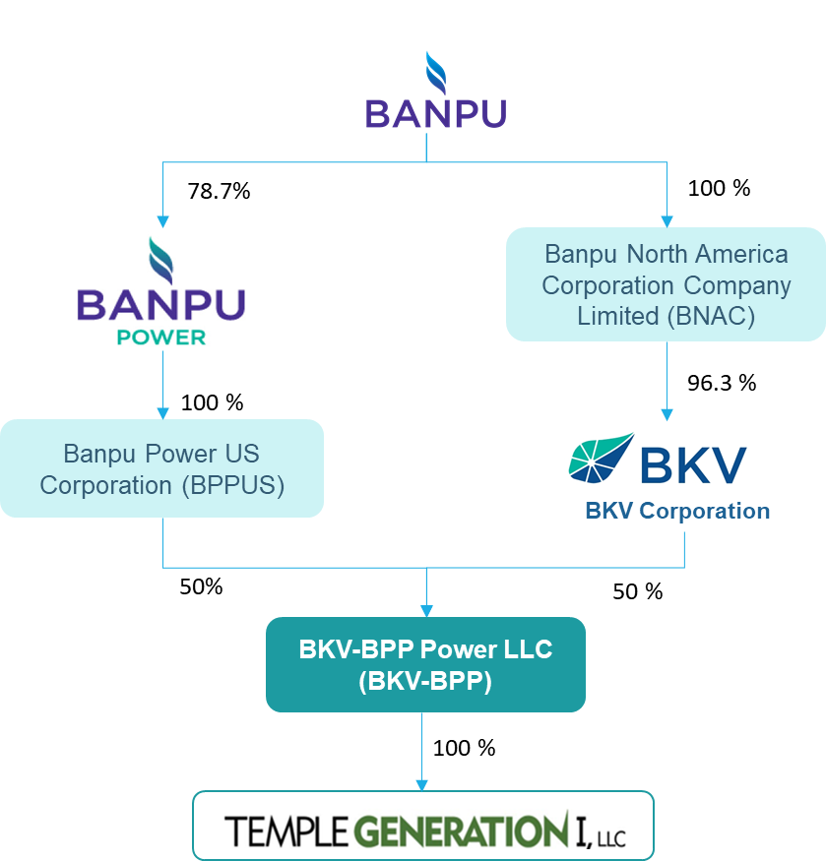

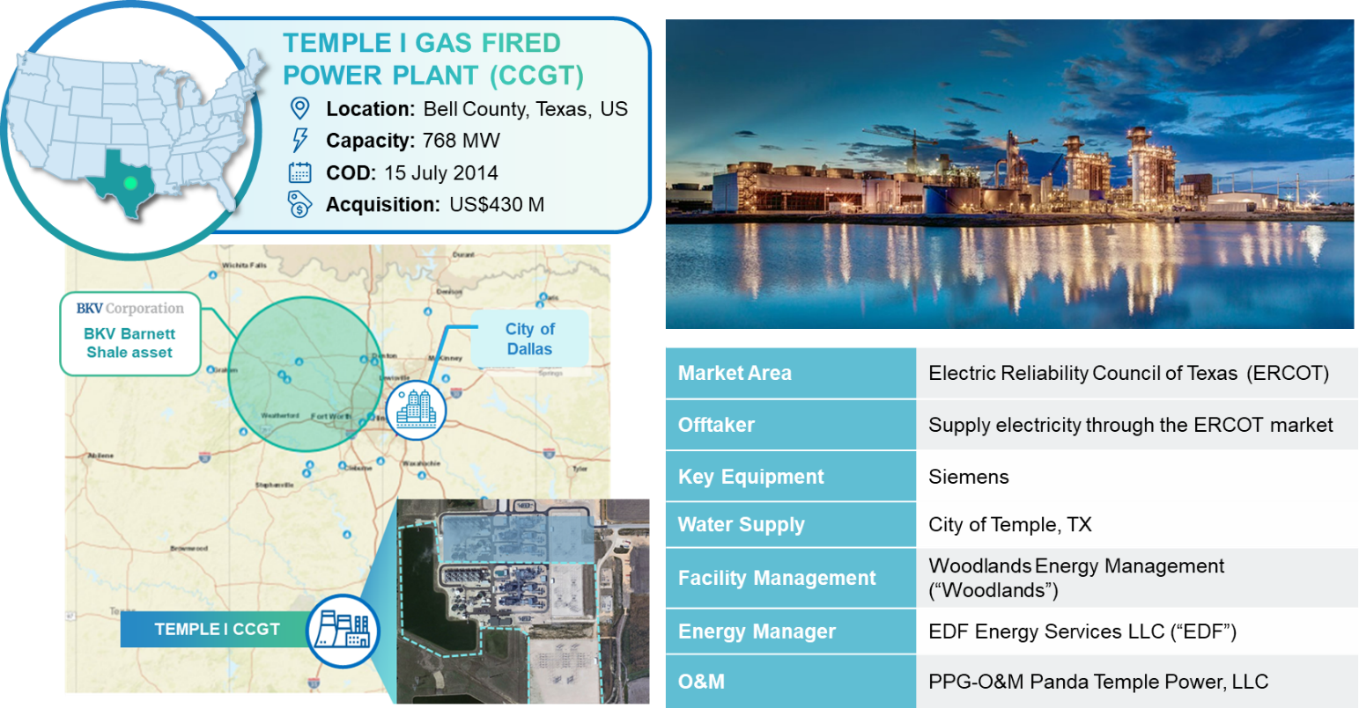
Temple I CCGT power plant information

